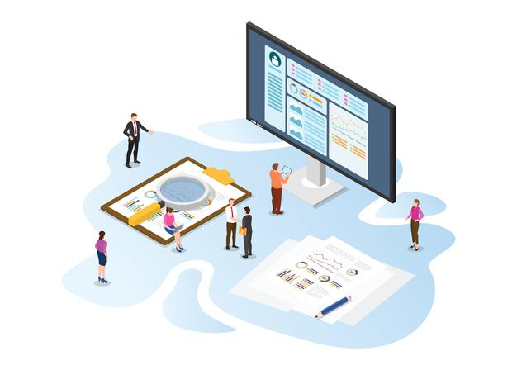

Assessment 4 Proposal

**Machine Learning-Based Counterfeit Drug Detection System**

**Detection Syst**

March 8, 2025

Team Members:

* Md. Khairul Kabir Bhuiyan
* [Team Member 2]
* [Team Member 3]
* [Team Member 4]

**Assessment 4 Proposal: Machine Learning Project**

**Problem Statement**

**Addressing the Threat of Counterfeit Medicines in the Pharmaceutical Industry**

The increasing number of counterfeit medicines in the pharmaceutical supply chain poses significant health risks. According to the World Health Organization (WHO), approximately 10% of medical products in low- and middle-income countries are either substandard or falsified. Counterfeit medicines not only compromise patient safety but also contribute to treatment failures, drug resistance, and fatalities, significantly impacting global healthcare systems. These counterfeit drugs often contain incorrect doses of active ingredients or harmful substances, leading to severe medical complications and loss of life.

Counterfeit drug trade is a multi-billion-dollar industry that threatens both public health and the reputation of pharmaceutical companies. Traditional methods of detecting counterfeit drugs, such as manual inspection and verification through packaging labels, are insufficient due to the increasing sophistication of counterfeiters. The lack of an automated and scalable solution makes it difficult for consumers, regulators, and pharmaceutical companies to identify counterfeit medicines effectively.

**Objective of the Project**

This project aims to develop a machine learning-based counterfeit drug detection system using a combination of image recognition and text-based verification techniques. By leveraging deep learning and artificial intelligence, the model will analyze multiple factors, including:

* **Drug packaging features** (logos, fonts, color schemes, and holograms)
* **Barcodes and serial numbers** for verification against a database of authentic medicines
* **Chemical composition analysis** (if applicable) to compare active ingredients

**Impact of the Solution**

By addressing this issue, our project will:

* Significantly reduce health hazards by preventing the consumption of counterfeit drugs
* Ensure medication safety through a reliable and efficient verification mechanism
* Enhance trust in the pharmaceutical industry by providing transparency and accountability
* Support regulatory bodies and pharmaceutical companies in tracking and eliminating counterfeit drugs from the market

The successful implementation of this project will help regulatory authorities, pharmaceutical companies, and consumers quickly identify counterfeit drugs and take necessary actions. This system has the potential to revolutionize drug authentication, offering a scalable and accessible solution to one of the biggest challenges in global healthcare today.

**Plan**

The development of the counterfeit drug detection system will follow a structured plan:

**Phase 1: Research & Data Collection**

* Conduct a thorough literature review on counterfeit medicine detection techniques.
* Source datasets from public repositories, pharmaceutical companies, and online sources.
* Identify data collection challenges and apply data augmentation to balance datasets.

**Phase 2: Model Development**

* Preprocess collected datasets by removing noise and standardizing formats.
* Train multiple deep learning models (CNNs, RNNs, and transformers) for image and text analysis.
* Evaluate model performance using accuracy, precision, recall, and F1-score.

**Phase 3: System Integration**

* Develop a user-friendly mobile and web application for drug verification.
* Implement an API to allow regulatory bodies and pharmacies to integrate the model into their existing systems.
* Test and refine the model to improve accuracy and reliability.

**Phase 4: Deployment & Monitoring**

* Deploy the solution on cloud-based infrastructure for real-time access.
* Continuously monitor the system’s performance and improve it with additional data.
* Educate consumers and stakeholders about counterfeit drug risks and prevention measures.

**Benefits**

The implementation of this counterfeit drug detection system offers multiple advantages:

**1. Improved Healthcare Safety**

* Reduces health risks associated with counterfeit drugs.
* Ensures that patients receive only authentic and safe medications.

**2. Increased Consumer Trust**

* Empowers consumers to verify medications before consumption.
* Builds confidence in pharmaceutical brands and healthcare providers.

**3. Enhanced Regulatory Enforcement**

* Assists government agencies in detecting and eliminating counterfeit drugs.
* Helps in enforcing stricter regulations and punishing fraudsters.

**4. Protection of Pharmaceutical Industry**

* Reduces financial losses caused by counterfeit drug sales.
* Protects the reputation of legitimate pharmaceutical companies.

**5. Scalable and Global Solution**

* Can be deployed across different regions and adapted to various pharmaceutical markets.
* Enables global organizations to work together in the fight against counterfeit drugs.

**Dataset Sourcing and Challenges**

We plan to source datasets from multiple sources:

**Data Sources:**

1. Public Datasets: Open-source pharmaceutical image datasets from Kaggle, WHO, and research institutions.
2. Industry Collaborations: Partnering with pharmacies, hospitals, and regulatory bodies to collect authentic and counterfeit drug samples.
3. Synthetic Data Generation: Using data augmentation techniques to generate counterfeit drug images if the dataset is imbalanced.
4. Web Scraping: Extracting images and details from legitimate pharmaceutical websites and online medicine verification databases.

**Challenges in Data Collection:**

* **Limited Availability**: Authentic counterfeit drug datasets are scarce.
* **Data Privacy**: Some pharmaceutical data might be restricted due to regulations.
* **Class Imbalance**: Authentic drugs far outweigh counterfeit samples, requiring data augmentation techniques.
* **Variability in Packaging**: Different pharmaceutical companies use different packaging designs, making standardization difficult.

**Dataset Example:**

The dataset will contain:

* **Image Data**: High-resolution images of authentic and counterfeit drug packaging.
* **Text Data**: Barcode numbers, serial numbers, and manufacturer details.
* **Chemical Composition**: Information about drug ingredients for further validation.

**Visual Representation of the Dataset Approach**

Below is an example flowchart depicting how the dataset will be collected and preprocessed:

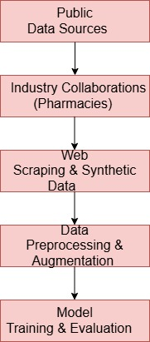

**Context Diagram**

To illustrate the overall flow of the system, the **context diagram** below presents a high-level view of interactions between the model and various stakeholders:

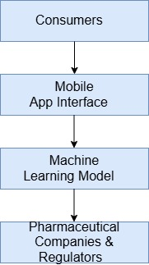

**Context Diagram Description:**

* **Consumers**: Users scan drug packaging through a mobile app.
* **Mobile App Interface**: Captures images and relevant text-based details.
* **Machine Learning Model**: Processes data and verifies authenticity.
* **Pharmaceutical Companies & Regulators**: Receive flagged counterfeit reports for action.

**Model Usage and Application**

If an acceptable model performance is achieved, it can be integrated into various real-world applications:

**1. Mobile Application for Consumers**

Consumers can use a **mobile app** to scan drug packaging and verify authenticity using the trained model. The app will provide:

* Instant verification results (Authentic or Counterfeit)
* Detailed manufacturer information
* Warnings if counterfeit drugs are detected

**2. Regulatory Enforcement Tool**

Government agencies and drug regulators can use the model to:

* Monitor counterfeit drug distribution
* Take legal actions against counterfeit suppliers
* Enhance the security of the pharmaceutical supply chain

**3. Integration into Pharmaceutical Supply Chains**

Pharmaceutical companies can embed the model in their logistics processes to:

* Scan and verify shipments before distribution
* Automate fraud detection in real-time
* Ensure compliance with global drug safety standards

**Expected Impact of the Model**

|  |  |
| --- | --- |
| **Aspect** | **Expected Benefit** |
| **Healthcare Safety** | Reduced health risks and fatalities |
| **Consumer Trust** | Increased confidence in drug purchases |
| **Regulatory Efficiency** | Faster counterfeit detection and enforcement |
| **Industry Protection** | Prevention of financial losses for pharma companies |

**Graphical Representation of Model Implementation**

The graphical representation outlines the workflow of the counterfeit drug detection system using machine learning techniques. Below is a step-by-step breakdown of how the system functions in real-world applications.

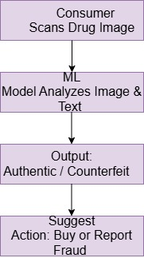

**Step 1: Consumer Scans Drug Image**

* A consumer or pharmacist uses a mobile app to scan the drug packaging or barcode.
* The app captures images of the packaging and extracts text details (batch number, serial number, manufacturer details).
* The captured data is sent to the machine learning model for analysis.

**Step 2: ML Model Analyzes Image & Text**

* The machine learning model processes the input data using deep learning techniques:
  + Image Processing: Analyzing packaging logos, fonts, color schemes, and security features.
  + Text Analysis: Verifying batch numbers and manufacturer details against official drug databases.
  + Barcode Matching: Cross-checking barcode information with pharmaceutical registries.
* If discrepancies or anomalies are detected, the model flags the drug as suspicious.

**Step 3: Output: Authentic / Counterfeit**

* The model classifies the drug as either Authentic or Counterfeit.
* The confidence score of the prediction is displayed to ensure transparency.
* A detailed report is generated, explaining the detected irregularities (if counterfeit).

**Step 4: Suggest Action: Buy or Report Fraud**

* If the drug is authentic, the app displays a safe to use confirmation.
* If the drug is counterfeit, the app alerts the user with:
  + A warning message advising them not to purchase or consume the drug.
  + An option to report the counterfeit product to regulatory authorities (e.g., WHO, FDA).
  + Information about the nearest authorized pharmacy to buy the correct medication.

**Conclusion**

This project aims to combat the growing threat of counterfeit medicines using advanced machine learning techniques. By integrating image processing, text verification, and deep learning, we can develop a highly effective solution for consumers, pharmaceutical companies, and regulatory bodies. The application of artificial intelligence in this domain enhances the efficiency of counterfeit detection, ensuring higher accuracy and real-time verification.

Beyond improving patient safety, the successful implementation of this project will strengthen pharmaceutical supply chain security and enable global regulatory compliance. This initiative has the potential to reduce counterfeit drug circulation, mitigate financial losses, and foster public trust in legitimate medicines. Furthermore, it aligns with international efforts to enhance healthcare security, ultimately saving lives and protecting public health.

This proposal provides a detailed framework for our machine learning project and demonstrates its feasibility in real-world applications. Let us know if any refinements are needed before submission.